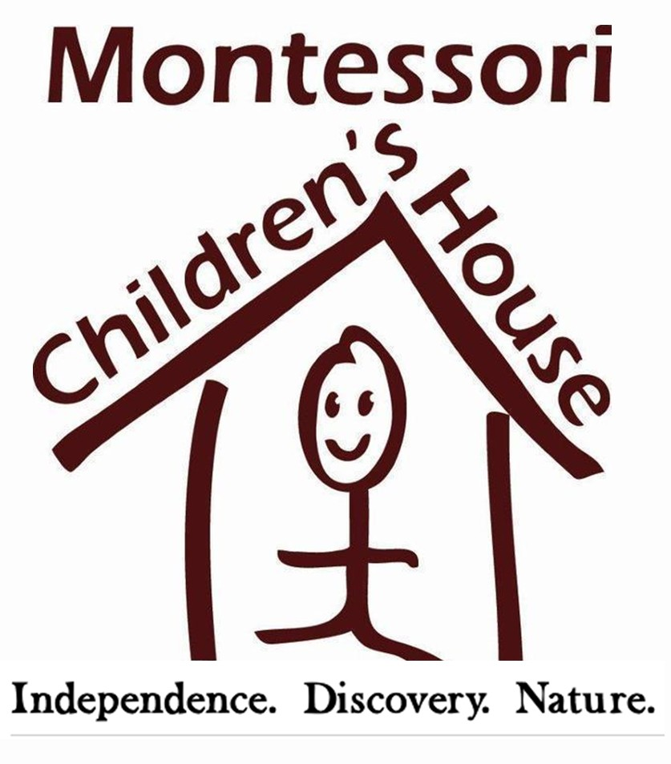

FOR RELEASE: CONTACT:
September 26, 2017 Georgie Hockett, Marketing/PR
georgienick@hotmail.com
206. 852. 2911
MCH HONORED AS BEST WOMAN-OWNED BUSINESS FINALIST

REDMOND, WA – Montessori Children’s House (MCH), an AMS-accredited Montessori school, was honored to be nominated in the Woman-owned Small Business of the Year category for the King County Executive’s Small Business Awards. The award presentation, which took place Thursday, September 21 at Meydenbauer Center in Bellevue, brought together top business owners including MCH’s Head of School Jennifer McConnell, recognized for their outstanding work and success as a female-owned business.

Over 200 small business owners, entrepreneurs, and supporters of small business from across the County attended the awards presentation, showing their support for this year's finalists and winners.

Jennifer McConnell, who has been with MCH for 15 years, took the school from 86 kids to 213 kids, and oversaw the construction of an additional school building -- the newest addition to the 5 acre-campus. Additionally, it was Jennifer’s vision that brought MCH’s organic central garden to life and introduced farm-animals onto the campus. MCH is a Whole Kids Foundation award-winning school, was named 425’s Best Preschool and is a King County Green certified school at Levels 1 & 2.

“It’s such an honor to be nominated,” said Jennifer. “We were in great company with the these three other woman-owned business. I’m already looking forward to being a part of the King County Executive’s Business Awards next year.”

As the only school nominated in the category, Jennifer attended the award breakfast along with her program directors and Admissions Director.
# # #
ABOUT MONTESSORI CHILDREN’S HOUSE
Founded in 1987, Montessori Children's House is an American Montessori Society accredited school in Redmond and Sammamish. MCH is committed to an authentic Montessori education with an emphasis on nature. The serene, five-acre campus in a farm-like setting connects students to their natural environment and encourages individualized learning. Visit MCHkids.com or MCH’s Facebook page to learn more.

ABOUT THE KING COUNTY EXECUTIVE’S SMALL BUSINESS AWARDS
King County Executive's Small Business Awards, as we recognize the achievements and accomplishments of small businesses throughout King County.

