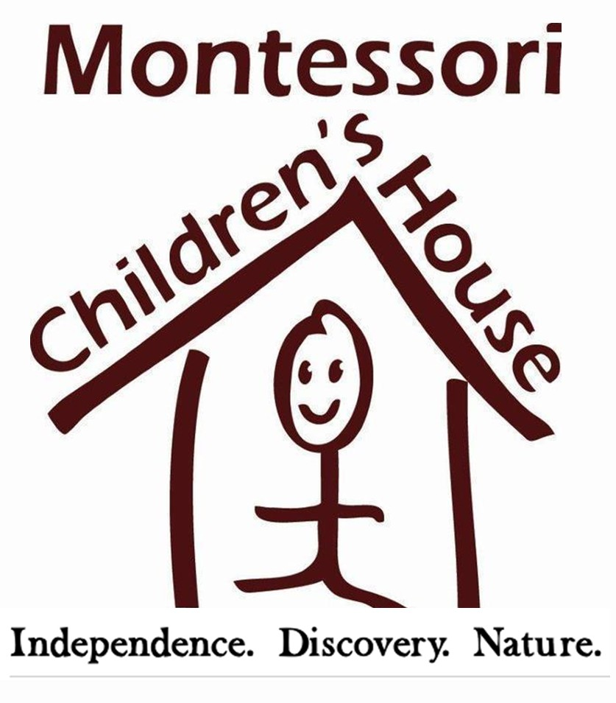

FOR RELEASE CONTACT
May 4, 2017 Georgie Hockett
206. 852. 2911
georgie@mchkids.com

Father and Daughter Businesses Make
425 Magazine’s BEST OF List
REDMOND, WA – They say the apple doesn’t fall very far from the tree and in this case, it might really be true. Craig Baker, owner of Bake’s Place in Bellevue, and daughter Jennifer Wheelhouse, owner of Montessori Children’s House (MCH) in Redmond, both found themselves (and their businesses) on the 2017 ‘Best Of’ list by 425 Magazine, released
April 24, 2017.

Bake’s Place, named 425’s Best Kept Secret + Nightclub, started in 2000 after being fueled by the passion and musical talents of Baker. MCH, named 425’s Best Preschool, was originally started by Wheelhouse’s mother, Linda Cole-Weaver, in 1987 before Jennifer Wheelhouse took over the reins in 2003.

“Entrepreneurship has always been a part of my family,” says Wheelhouse. “My dad had a full music venue in our backyard that held 200 people. He later expanded that to become Bake’s Place. Meanwhile, my mom started MCH …so going your own way and having a small business was absolutely a part of my family culture,” says Wheelhouse.

“It’s really fun to be on the Best Of list with Jennifer,” says Baker of sharing ‘Best Of’ honors with his daughter. “She doesn’t really come to me for advice, but that’s only because she doesn’t need it,” he jokes.
# # #

MONTESSORI CHILDREN’S HOUSE
Founded in 1987, Montessori Children's House is currently the only American Montessori Society accredited school in Redmond and Sammamish. MCH is committed to an authentic Montessori education with an emphasis on nature. Our serene, five-acre campus in a farm-like setting connects students to their natural environment and encourages individualized learning. Learn more at MCHkids.com.

BAKE’S PLACE
Bake’s Place has been the premiere jazz club destination since 2000. Serving an award-winning New American menu alongside of the country’s most established and up and coming jazz artists, Bake’s Place is where Eastsiders go for great food and amazing music. View upcoming performances at BakesPlaceBellevue.com.

