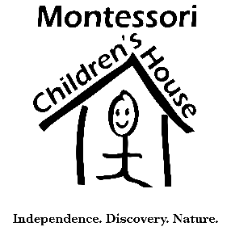

MCH PARENT COMMUNICTION

We want to make sure you don’t miss a thing for the 2015-2016 school year! Please let us know which email you prefer to receive all school communication.*

Student Name:_________________________________________

Class:________________________________________________

Parent 1 Name:_________________________________________

Parent 1 Email:_________________________________________

Parent 2 Name:_________________________________________

Parent 2 Email:_________________________________________

*If your email changes during the course of the year, please remember to send your updated email information to office@mchkids.com

