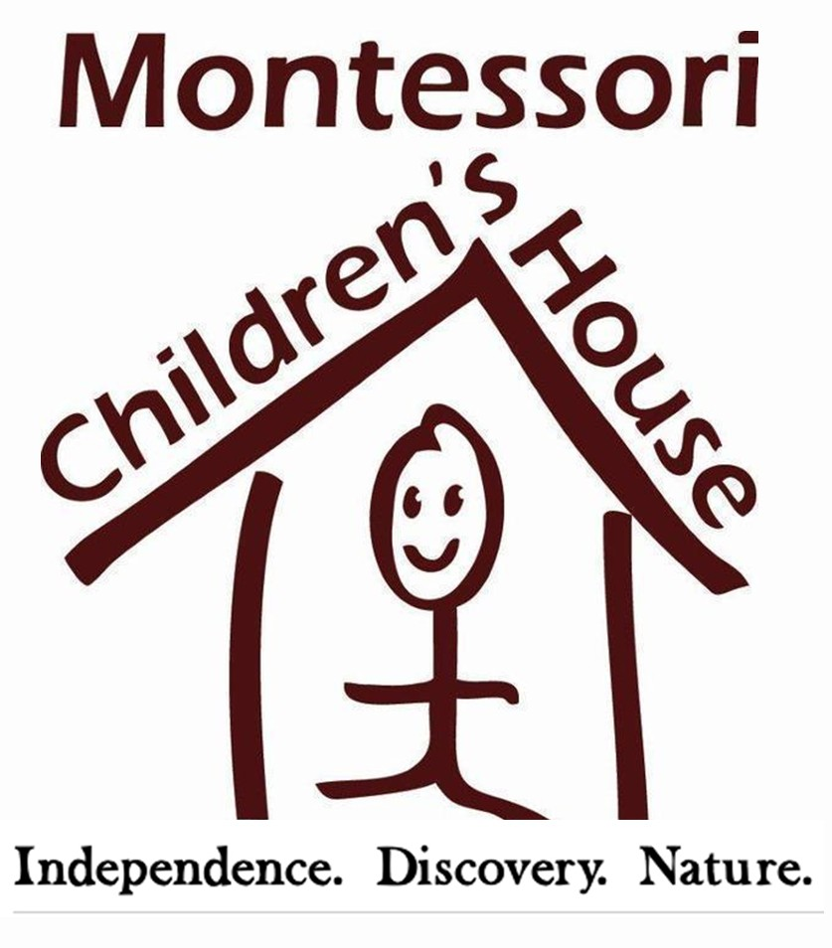

FOR RELEASE CONTACT
May 1, 2016 Georgie Hockett
206. 852. 2911
georgie@mchkids.com

Local School Wins BEST title and GREEN title
in the same month
REDMOND, WA – There was much to celebrate at Montessori Children’s House (MCH) in April. Not only did the school earn Pillar 3 status as determined by the US Department of Education, the school also took home the coveted 425 Best Preschool award.

MCH, an accredited American Montessori Society school, worked hard to build on the Pillar 2 award they earned in 2016. This year, the school that serves student from 6 weeks to sixth grade made a concentrated effort to create healthy lifestyle choices for their staff and students by using green-approved cleaners and growing their own snack food in their centrally-located, organic garden. A state representative from the US Department of Education presented the student-led Green Team with the award in an intimate ceremony on their elementary playground – which is made of repurposed wood (such as downed trees) and recycled drainage pipes.

The honors kept on coming when two weeks later, the Early Childhood Program at MCH won Best Preschool as voted by 425 magazine readers.
“Offering an authentic Montessori education with an emphasis on nature is absolutely what we’re all about here at MCH,” says Head of School, Jennifer Wheelhouse. “So to win another pillar by the US Department of Education and then to be recognized as the Best Preschool on the eastside, I think these two honors absolutely have to do with one another. We are very proud-- I am so thankful for everyone who voted for MCH in 425’s Best Of.”

# # #

MONTESSORI CHILDREN’S HOUSE
Founded in 1987, Montessori Children's House is the only American Montessori Society accredited school in Redmond and Sammamish. MCH is committed to an authentic Montessori education with an emphasis on nature. Our serene, five-acre campus in a farm-like setting connects students to their natural environment and encourages individualized learning. Learn more at MCHkids.com.

