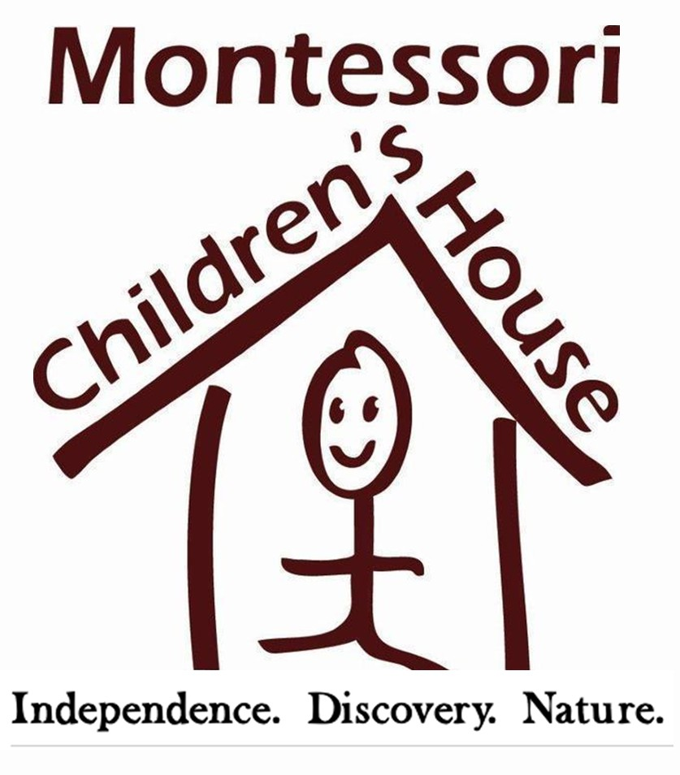

FOR RELEASE CONTACT
August 10, 2020 Georgie Hockett
206. 852. 2911
georgie@mchkids.com

School Completes School Mural
Two Years in the Making
REDMOND, WA – Call it a little bit of Italy on the eastside. Inspired by Gaudi mosaics during a trip to Italy, Montessori Children’s House (MCH) Head of School, Jennifer McConnell put Art Specialist, Michelle Dias, up to a challenge: Create a mosaic wall outside of the school’s newest building. While it may have started out as a simple enough request, Dias poured all of her creativity into the project, resulting in a comprehensive project spanning two years.

The project kicked off with a meeting between Dias and the students. Because the wall faced the school’s pollinator garden, the students decided that a work that included bees, butterflies and flowers was appropriate. The wall also included the student’s handprints, an inspirational element from Dias’ youth – her mother led a hand print mosaic project when she was in 6th grade. “I wanted the kids' hands to be reaching up, like they're growing in the garden, and the teachers' hands reaching down from the top to help pull the children up with knowledge,” Dias said.

All of the pieces were handmade, using slabs of hi-fire clay. Students used different types of lace, stamps, leaves and other items to create different textures by rolling them into the clay. The kids also planned and sketched different insects, flowers and animals, then created clay tiles based on their sketches. MCH students between ages 6 and 13 were involved in every part of the process, from planning to creating the pieces; glazing to installing the art on the wall.
It took years to make enough pieces to cover the entire wall. “Every year we worked on it, which was three school years,” explained Dias. “The kids that moved up from the Early Childhood Program into the elementary school, or were new to the school, made a hand print so they could be included in the project. We included many MCH alumni's handprints too.”
Because the students have been away from campus since early March, Dias describes “an indescribable joy” watching their faces light up when students returned for summer camp to see a completely finished mural, framed by a thriving pollinator garden. “It’s an reminder of the indestructible bond that exists in our community. We’re all the parts that make up the whole of MCH… just like the mosaic.”
# # #
MCH (MONTESSORI CHILDREN’S HOUSE)
Nurture AND Nature; developing your child's individual passions and strengths. Because today's child is tomorrow's future.

Montessori Children's House is an AMS accredited Montessori school for children six weeks through eighth grade. Committed to an excellent holistic Montessori education that includes the partnership and involvement of families within our community, MCH is inspired by a growth mindset and is dedicated to serving the individual educational needs for children of all backgrounds.

MCH’s beautiful five-acre campus is surrounded by protected wetlands and forested areas and is home to several farm animals including goats, chickens, rabbits, ducks and more. With a fully enclosed Nature Trail, well-developed enrichment and extracurricular programs, this farm-like peaceful setting connects MCH students to their natural world.
​

